Cross-quantilogram: AUDUSD and USDJPY
Method 20 / daily log returns / expanding quantiles / Alpari D1 full available history

Study setup
Logical pair: AUDUSD , USDJPY
Broker symbols: AUDUSD_i , USDJPY_i
Snapshot: 2026-11-03_majors_alpari_D1
Timeframe: D1
Matched return window: 1999-01-05 to 2026-11-02 (UTC bar dates)
Matched return count n: 7199
Dropped unfinished last bar dated 2026-11-03 UTC after a tick-volume check against the prior complete day.
Quantiles: expanding window, min history 252 days
tau in [0.05, 0.2]; k=0..10; headline tau=0.05, k=1
Complete matched rows (Excel): AUDUSD-USDJPY_CQ_D1.xlsx
Complete matched rows (HTML table): AUDUSD-USDJPY_CQ_D1_data.html

Method carried forward
The cross-quantilogram rho_tau(k) measures linkage among centered quantile-hit indicators of matched daily log returns of close, ln(close_t / close_t-1). Quotes are not inverted. At each date t, the tau-quantile uses only returns through t (expanding window) after a minimum history of 252 days. Hits are h_t = 1(r_t < q_t) - tau. rho_tau(k) is the normalized cross-product of h_x,t with h_y,t+k. Levels tau in {0.05, 0.20} and lags k=0..10 are pre-specified; headline is tau=0.05, k=1 both directions. Same-sample Pearson r is a side check. This is not causation and not a trading signal.

Results (headline)
rho_AUDUSD->USDJPY(tau=0.05,k=1): 0.024054
rho_USDJPY->AUDUSD(tau=0.05,k=1): 0.057615
rho_AUDUSD->USDJPY(tau=0.20,k=1): 0.015656
rho_USDJPY->AUDUSD(tau=0.20,k=1): 0.025272
Pearson r: -0.088151

CQ table (tau=0.05)
k | rho_AUDUSD_to_USDJPY | n_AUDUSD_to_USDJPY | rho_USDJPY_to_AUDUSD | n_USDJPY_to_AUDUSD
0 | 0.13816626 | 6948 | 0.13816626 | 6948
1 | 0.02405429 | 6947 | 0.0576145 | 6947
2 | 0.02740215 | 6946 | 0.0441824 | 6946
3 | 0.02068183 | 6945 | 0.05759869 | 6945
4 | 0.06094689 | 6944 | 0.03409804 | 6944
5 | 0.02737767 | 6943 | 0.04080221 | 6943
6 | 0.01730102 | 6942 | 0.01058869 | 6942
7 | 0.03407373 | 6941 | 0.03742992 | 6941
8 | 0.0474905 | 6940 | 0.02735319 | 6940
9 | 0.03741377 | 6939 | 0.01392004 | 6939
10 | 0.05083079 | 6938 | 0.05083079 | 6938

Conclusion
Headline tau=0.05, k=1 for AUDUSD and USDJPY: rho_AUDUSD->USDJPY = 0.0241; rho_USDJPY->AUDUSD = 0.0576. At tau=0.20, k=1: 0.0157 and 0.0253. Same-day tau=0.05 rho(k=0) = 0.1382. Pearson r = -0.0882. This is quantile-hit linkage, not a trading signal.

Charts
Daily closes

Daily log returns

Cross-quantilogram tau=0.05
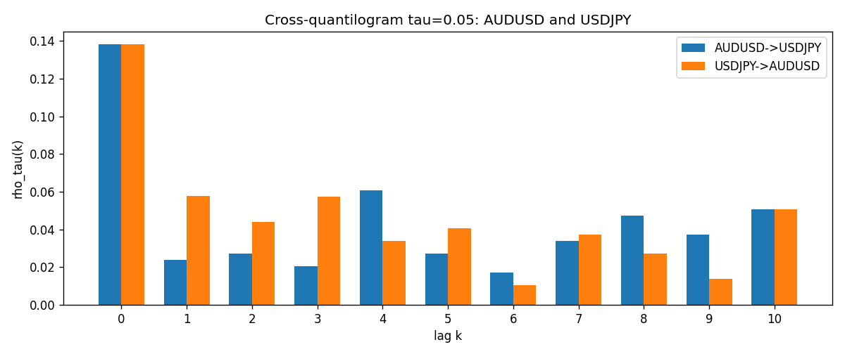

Data report
Matched rows and the CQ sheet are in the sibling Excel workbook named AUDUSD-USDJPY_CQ_D1.xlsx. Embedding all rows as a Word table is impractical; this file holds column summaries and the first and last 15 matched rows.
Columns: time, AUDUSD_open, USDJPY_open, AUDUSD_high, USDJPY_high, AUDUSD_low, USDJPY_low, AUDUSD_close, USDJPY_close, AUDUSD_tick_volume, USDJPY_tick_volume, AUDUSD_spread, USDJPY_spread, AUDUSD_real_volume, USDJPY_real_volume, AUDUSD_log_return, USDJPY_log_return, AUDUSD_h_t005, USDJPY_h_t005
Column summaries (matched calculation rows)
column | count | mean | std | min | 25% | 50% | 75% | max
AUDUSD_open | 7199 | 0.75196998 | 0.13527571 | 0.4785 | 0.661035 | 0.73142 | 0.809135 | 1.10284
USDJPY_open | 7199 | 113.81114 | 19.206896 | 75.693 | 104.4285 | 110.984 | 120.6925 | 163.824
AUDUSD_high | 7199 | 0.75602148 | 0.13583632 | 0.4878 | 0.6647 | 0.7349 | 0.815325 | 1.10795
USDJPY_high | 7199 | 114.30872 | 19.268446 | 76.001 | 104.881 | 111.442 | 121.26 | 163.978
AUDUSD_low | 7199 | 0.7479145 | 0.13459018 | 0.4775 | 0.6577 | 0.72758 | 0.80425 | 1.0975
USDJPY_low | 7199 | 113.28779 | 19.134887 | 75.402 | 103.89 | 110.53 | 120.17 | 163.628
AUDUSD_close | 7199 | 0.75202255 | 0.13525884 | 0.4786 | 0.661195 | 0.73175 | 0.809235 | 1.10169
USDJPY_close | 7199 | 113.824 | 19.222288 | 75.811 | 104.42 | 111.025 | 120.687 | 163.851
AUDUSD_tick_volume | 7199 | 77366.826 | 138149.99 | 109 | 5440 | 43349 | 71344.5 | 1234623
USDJPY_tick_volume | 7199 | 106151.62 | 179316.41 | 197 | 9927 | 53098 | 92761 | 1803508
AUDUSD_spread | 7199 | 30.814558 | 16.886804 | 0 | 13 | 30 | 50 | 50
USDJPY_spread | 7199 | 20.321434 | 17.631726 | 0 | 6 | 11 | 30 | 50
AUDUSD_real_volume | 7199 | 5.2435469e+09 | 1.2539788e+11 | 0 | 0 | 0 | 0 | 3.811512e+12
USDJPY_real_volume | 7199 | 3.470603e+10 | 1.6078743e+11 | 0 | 0 | 0 | 0 | 3.8834203e+12
AUDUSD_log_return | 7199 | 2.78e-05 | 0.00754502 | -0.08602525 | -0.00385397 | 0.00028846 | 0.00415332 | 0.0806166
USDJPY_log_return | 7199 | 4.761e-05 | 0.00620532 | -0.03908203 | -0.00320306 | 0.00011368 | 0.00340781 | 0.05184024
AUDUSD_h_t005 | 6948 | -0.00336788 | 0.21086481 | -0.05 | -0.05 | -0.05 | -0.05 | 0.95
USDJPY_h_t005 | 6948 | -0.00682211 | 0.20327201 | -0.05 | -0.05 | -0.05 | -0.05 | 0.95
First 15 matched rows (selected columns)
time | AUDUSD_log_return | USDJPY_log_return | AUDUSD_h_t005 | USDJPY_h_t005
1999-01-05 | -0.00080418179 | -0.00017868311 | nan | nan
1999-01-06 | 0.011836351 | 0.0075660159 | nan | nan
1999-01-07 | 0.0088650256 | -0.012851583 | nan | nan
1999-01-08 | 0.00031515916 | -0.0047719894 | nan | nan
1999-01-11 | 0.0072213815 | -0.016195423 | nan | nan
1999-01-12 | -0.0048608485 | 0.032310364 | nan | nan
1999-01-13 | -0.0078902098 | 0.0081373171 | nan | nan
1999-01-14 | -0.002696916 | 0 | nan | nan
1999-01-15 | 0.007123101 | 0.0055343401 | nan | nan
1999-01-18 | 0.00094592471 | 8.7600193e-05 | nan | nan
1999-01-19 | 0.0072225153 | -0.0056219403 | nan | nan
1999-01-20 | 0.0012507819 | -0.0053879917 | nan | nan
1999-01-21 | 0.00078094498 | 0.0084664056 | nan | nan
1999-01-22 | -0.012252745 | 0.0060412564 | nan | nan
1999-01-25 | -0.0039591468 | -0.0073594164 | nan | nan
Last 15 matched rows (selected columns)
time | AUDUSD_log_return | USDJPY_log_return | AUDUSD_h_t005 | USDJPY_h_t005
2026-10-13 | 0.0035007712 | -0.0018932826 | -0.05 | -0.05
2026-10-14 | -0.0015193215 | 7.5800166e-05 | -0.05 | -0.05
2026-10-15 | -0.0075447063 | -0.0018524319 | -0.05 | -0.05
2026-10-16 | 0.0033906408 | -0.00037976126 | -0.05 | -0.05
2026-10-19 | 0.0050859986 | 0.0034946841 | -0.05 | -0.05
2026-10-20 | 0.0034620426 | -0.0022546642 | -0.05 | -0.05
2026-10-21 | 0.0036066384 | -0.00032883504 | -0.05 | -0.05
2026-10-22 | -0.0012672558 | -0.0085942669 | -0.05 | -0.05
2026-10-23 | 0.0023765656 | 0.00035080446 | -0.05 | -0.05
2026-10-26 | -0.0032032829 | 0.0041238746 | -0.05 | -0.05
2026-10-27 | 0.0016669876 | 0.0027651658 | -0.05 | -0.05
2026-10-28 | 0.0040915541 | -0.00095679538 | -0.05 | -0.05
2026-10-29 | -0.0040915541 | -0.00038043789 | -0.05 | -0.05
2026-10-30 | 0.0010102376 | -0.0010596481 | -0.05 | -0.05
2026-11-02 | -0.0049184984 | 0.0026438521 | -0.05 | -0.05

